**GIT ENVIRONMENT SETUP**

Step 1 : Check if git is already installed.

# rpm –qa git



If not installed, so install it via yum or you it download it from git site and install.

Step 2 : Install git

#yum install git



OR

#wget <https://git-scm.com/download/linux/git-1.8.3.1-12.el7_4.x86_64.rpm>



#rpm –ivf git-1.8.3.1-12.el7_4.x86_64



Step 3 : Signup and create a account on GitHub

Open github site and create your account.

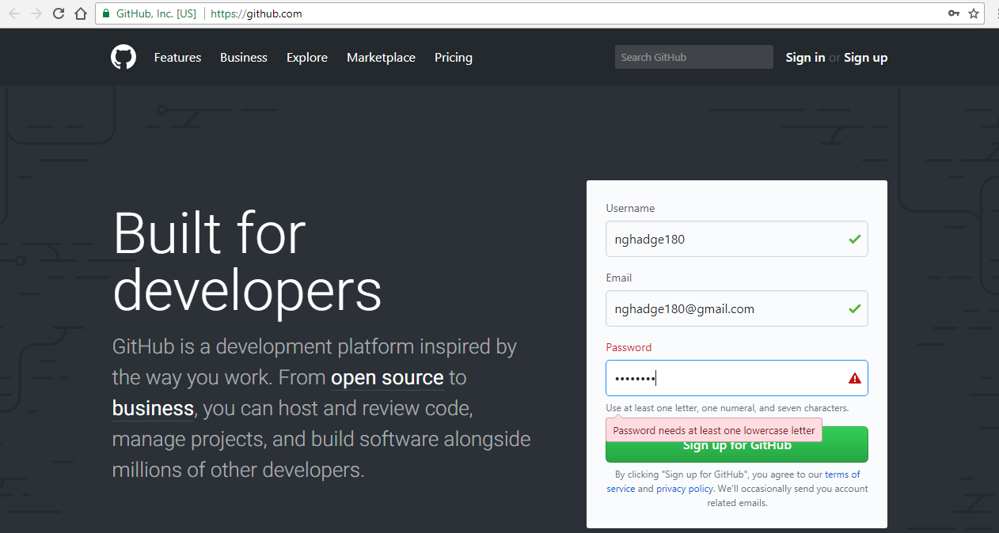

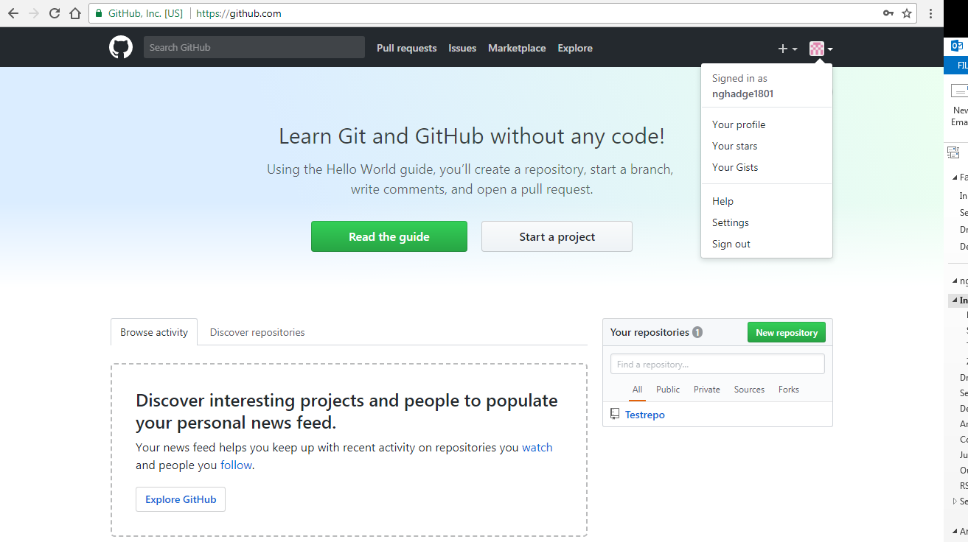

Step 4 : Add your github email and username to git

# git config --global user.name "nghadge1801"



# git config --global user.email nghadge1801@email.com



Step 5 : Create git repository & add file/folders to git

# mkdir /Test-repo

# cd /Test-repo

# git init

# git status

# git add

# git commit -m “…..”

# git push